Answers to Problems from the 200 NABCEP PV Installer Study Guide™ relative to Stand-Alone, Off Grid, or Battery Based Systems

51. The charge controller battery temperature sensor should be connected to:

a. the side of the battery compartment
b. the top of a battery that is at the end of a row of batteries
c. the bottom of any battery
d. on the side of a battery between 2 batteries

This location is most representative of the average battery temperature

52. The charge controller connected to the PV output circuit of Figure 4 normally requires adjustment for

a. voltage drop
b. battery type
c. maximum input power
d. maximum input current

Figure 4:
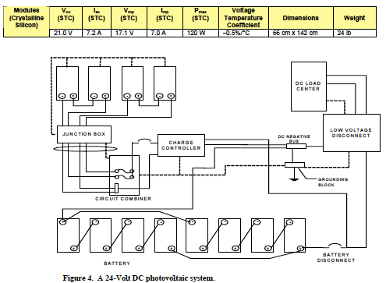

Read SG text to find details to answer. Batteries: section 3.5.5

53. Suppose an alternate series three-stage controller is available as a backup to a parallel three-stage PV charging source such as a utility-interactive battery based inverter. Suppose, also, that the PV source is intended to be the dominant charging source. To ensure that the PV source is the dominant charging source, one should

a. set the float voltage of the PV charging source higher than the bulk voltage of the alternate controller
b. set the float voltage of the PV charging source lower than the bulk voltage of the alternate controller
c. set the bulk voltage of the PV charging source lower than the float voltage of the alternate controller
d. set the absorption mode time of the PV charging source lower than the absorption time of the alternate controller

c. If the PV bulk setting is lower than the alternate float setting on the back up charge controller, the PV charing source will always be the dominan charging source unless it is deactivated, as when a utity-iteractive battery-based inverter goes into standby during a utility outage.

54. Four 6-volt 240-Ah batteries manufactured by manufacturer A, and four 6-volt 120-Ah manufactured by manufacturer B are available. IT is acceptable to incorporate all of these batteries into a 12-volt PV battery storage bank under the following circumstances”

a. If the 240-Ah batteries are connected in 3 series groups and the 120-Ah batteries are connected in 2 series groups, and then the four series groups are connected in parallel
b. If the 240-Ah batteries are all connected in parallel, the 120-Ah batteries are connected in parallel, and then the two parallel sets of batteries are connected in series
c. If each 240-Ah battery is connected in series with a 120-Ah battery, and then the four sets are connected in parallel.
d. There is no acceptable connection of the batteries into a single battery bank.

d. Choice a. would result in an overcharge of the 120Ah batteries, choice b would be even more serious overcharging of these atteries, choice c, would also result in overchargin. It is not OK to mix battery types in battery banks.

55. A good reason for large wire sizes in battery interconections, even if they are oversized for ampacity, is to

a. keep all battery currents as equal as possible
b. provide a lower resistance path for battery short circuit currents
c. allow for increase in load size or array size
d. better secure the batteries in case of high winds
a. This is discussed in the study guide text- see section 3.5.5.2.

56. The purpose of a linear current booster is to

a. keep its output voltage the same as its input voltage and boost the output current to a value larger than the input current
b. convert a high input voltage and low input current to a lower output voltage and a higher output current
c. convert a low input voltage and a high input current to a higher input voltage and a lower input current
d. keep it’s output current the same as its input current and boost the output voltage to a value larger than the input voltage.

b. This is the normal operating mode of a LCB. A MPT will also convert a low-input voltage and a high inpt crrent into a higher output voltage andf a lower output current if reqwuired to supply maximum power to the load.

A key here is to think about what the question says, what is implied logically by the title- for example- you can immediately illiminate c. because we are talking about a current booster, for example, not a way of boosting voltage. Answer b. is logical because of the nature of Ohms law and Current and Voltage balancing eachother.

57. The purpose of an inverter is to

a. convert DC at one voltage to AC at the same or another voltage
b. convert AC at one voltage to DC at the same or a different voltage
c. convert DC at one voltage to DC at another voltage
d. convert AC at one voltage t DC at another voltage

63. If the PV array in figure 9 [next page] is operated at a minimum temperature of -20ºC, then the charge controller maximum input voltage rating must be at least

a. 29.2 V
b. 34.3 V
c. 42 V
d. 49.6 V

d. Voc is 21.2V and the diagram shows 2 in series [3 series in parallel]. This means the voltage must be doubled to 42.4V. Then the temperature must be considered. Table 60.7 gives the multiplier for temperature correction as 1.18 for -20ºC.
42.4 V x 1.18 CF = 49.6 V

Figure 9:
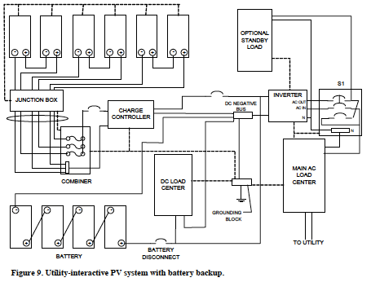

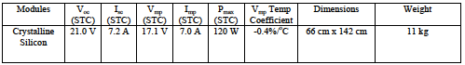

70. a 5-kVA 120-V generator is used as a backup generator for a system designed with 2 days of battery storage to 80% depth of discharge. If the generator is sized for a charging rate of C/10, and the generator burns 1 gallon of fuel per hour of run time, the average fuel consumption when the generator is the only power source will be closest to

a. 4 gallons
b. 5 gallons
c. 8 gallons
d. 10 gallons

a. The batteries will discharge 40% per day, so the generator will need to run for 4 hours per day. See section 3.5.7.2
It is suggested that in 2 days, batteries would be discharged 80%. That is 40% per day. At C/10, that is 4 hours.

71. If the 5-kVA, 120-V generator is protected with a 50-A circuit breaker, then the equipment grounding conductor must be no smaller than

a. 12AWG copper
b. 10 AWG copper
c. 8AWG copper
d. 6AWG copper

b. See NEC 250.122

